**Shell Scripting(Tech Arkit)**

**The sequence of commands written in one file and execute it, is nothing but shell scripting.**

To write simple script and execute

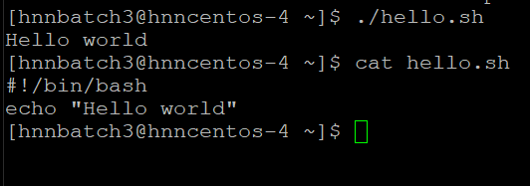

**Comments and Variables**

Comments are the line of code which are not executed but are helpful to know some information your scripts. We can write comments before command.

Variables are the containers to store some data inside. In shell there are two types of variables

1. System Variables --- maintained by OS
2. User defined Variables --- maintained by user

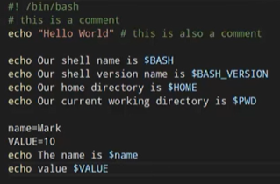

How to read input from terminal

Whenever you to take the input from terminal use read command

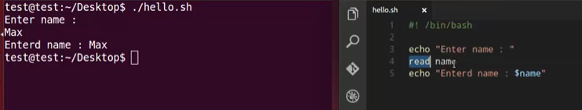

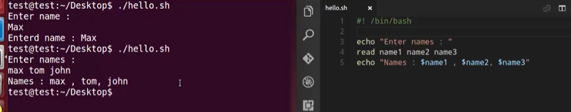

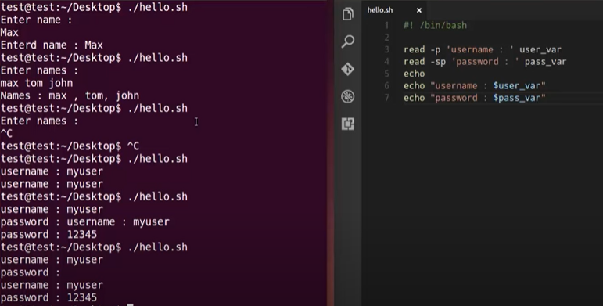

If Statement

The basic syntax is

If [ condition ]

Then

Statement

Fi

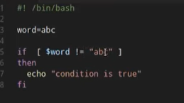

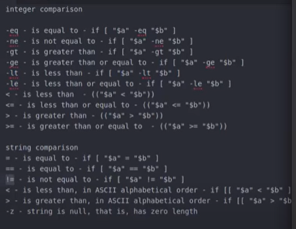

Else if condition

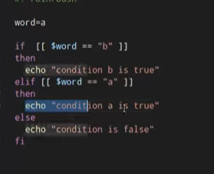

File test operations

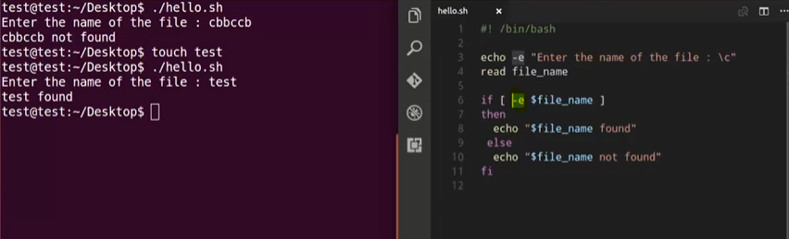

-e 🡺 To find the file

-s 🡺 check weather file is empty or not

-d 🡺 To find a directory

-f 🡺 To check weather file is excites and regular

-b 🡺 Block special file

-c 🡺 Character special file

-r 🡺 To check weather file have read permissions

-r 🡺 To check weather file have write permissions

-x 🡺 To check weather file have Execute permissions

**How to append output to the end of text file**

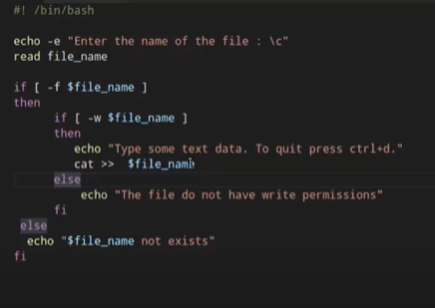

Logical AND operations

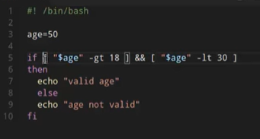 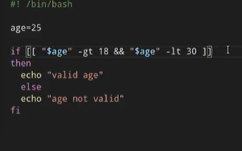

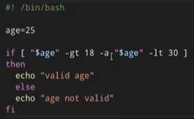

Logical OR operations

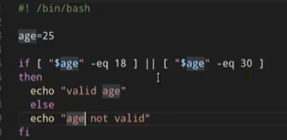 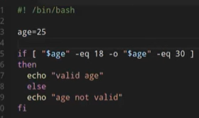

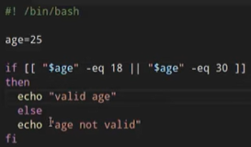

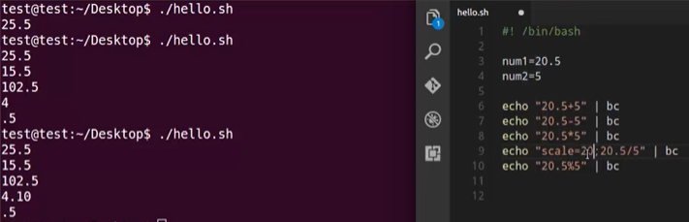

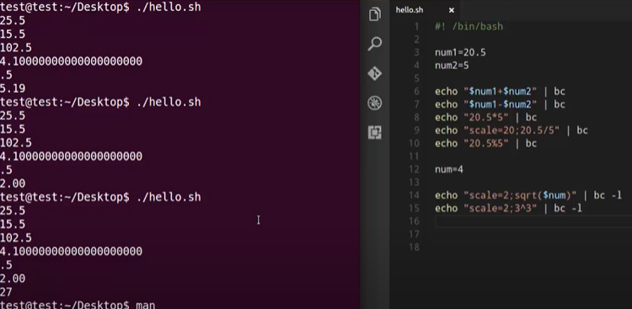

Case statement

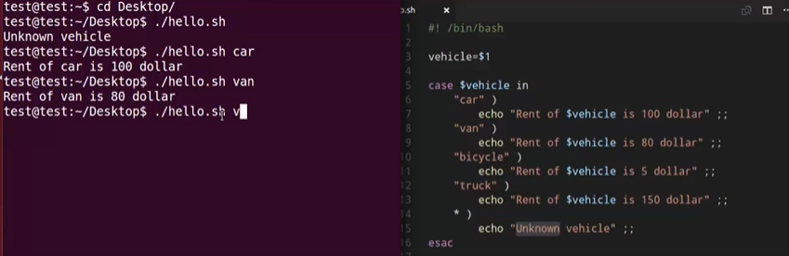

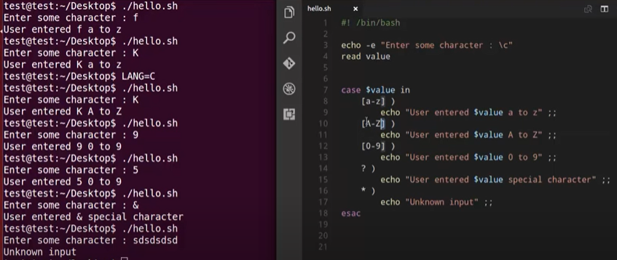

Array Variables

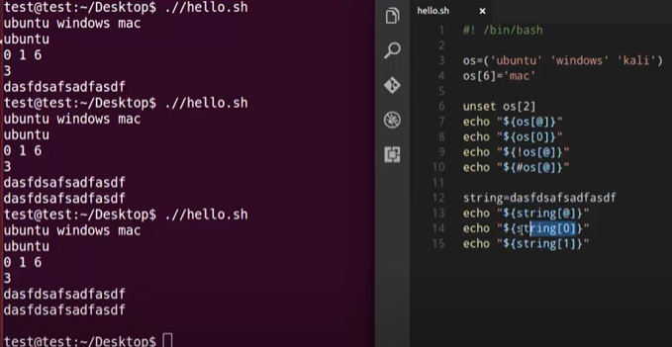

Loops

The loop is used to execute list of commands repeatedly.

While loop--- if condition is true it will execute

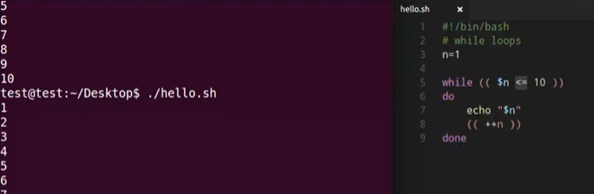

Until loop--- if condition is false it will execute

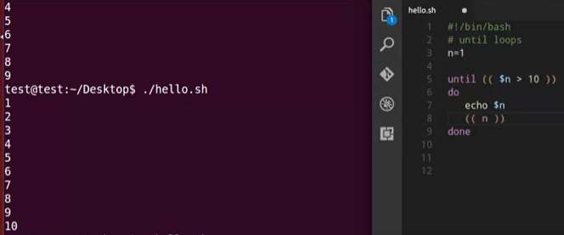

For loop ---- Is used to loop over list of value

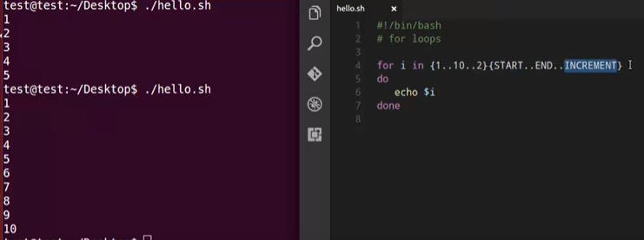

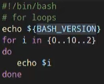 To check bash version 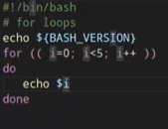

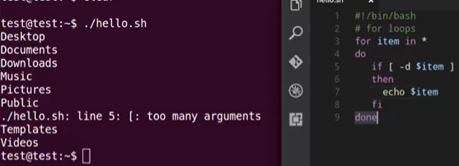

Select loop

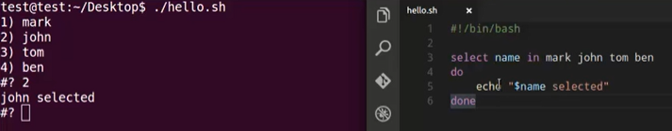

Break and Continue Statement

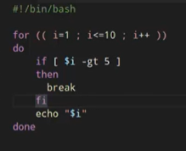 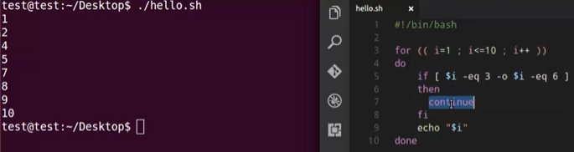

Functions

A function is a sub routine that implements set of operations.

Declare and calling a function

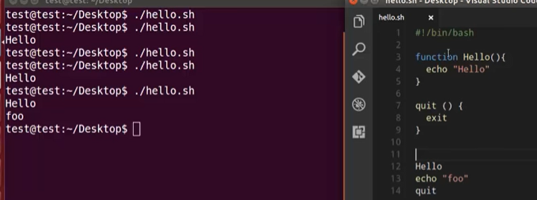

Passing arguments..

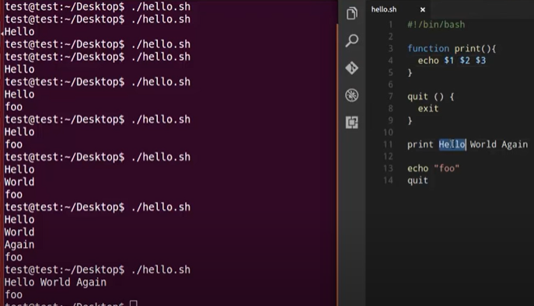

Local Variables

Read-only command can be used to create a variable or function readonly, that means we can’t reassign value of the variables .

To see all read only variables

Readonly -p -----in script

To see all read only functions

Readonly -f -----in script

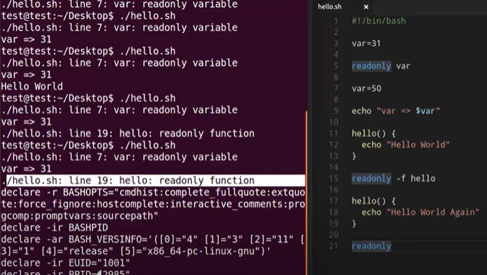

Signals and Traps

If you want to interrupt the script, while it’s in the process use below keys.

Ctrl+c ------- Interrupt the signal (sigint)

Ctrl+z -------- Suspend the signal (sigtstp)

Kill -9 <PID> --- do In another terminal (sigkill)

While doing process some unwanted signals come and interrupt the process, that’s way we are using Traps command.

Trap command will catch the unwanted signal.

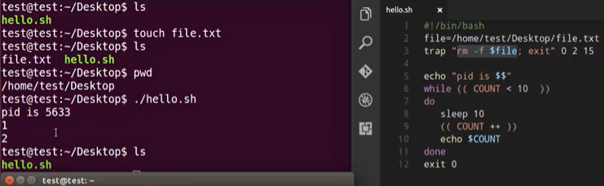

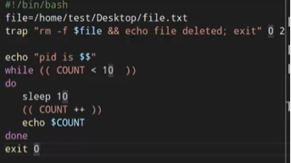

**Debug**

#bash -x <script name> ---- will give step by step execution of our script

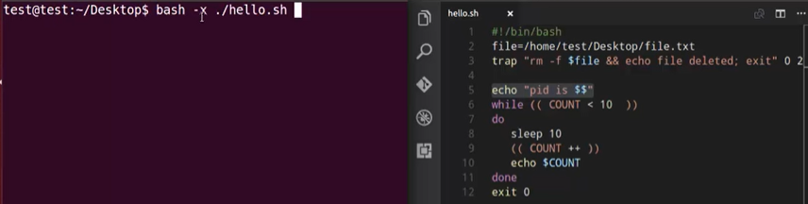

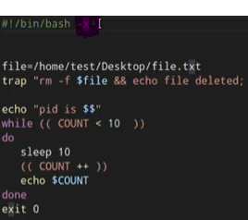 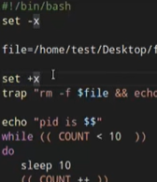

Set -x ---🡪 will debug the script

Set +x ---🡪 will stop the debug

Shell Scripting by Sai

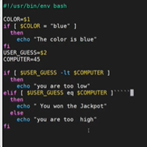 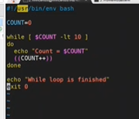 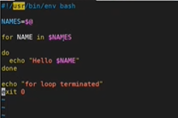 $@--- storing all the arguments

